You should get the Security Warning show below when you open the MIST Visit Builder.
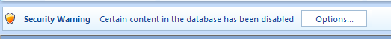

Close the Visit Builder splash screen by clicking on the X in the upper right corner
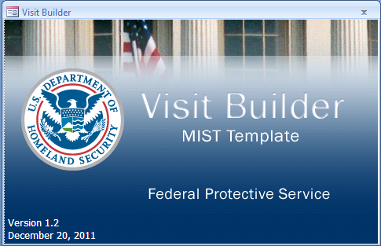

Click Options… on the Security Warning banner (see first screen shot)

The following window will appear
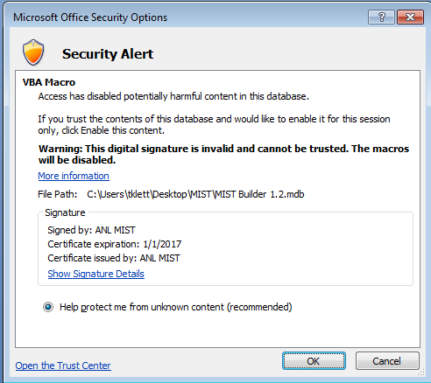
Click Show Signature Details
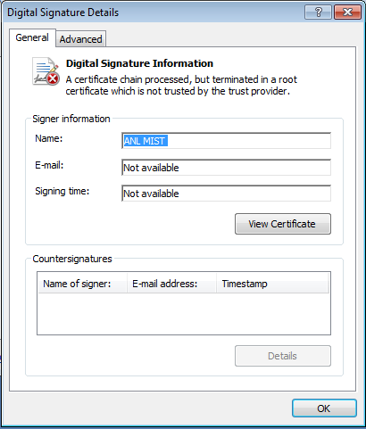
Click View Certificate
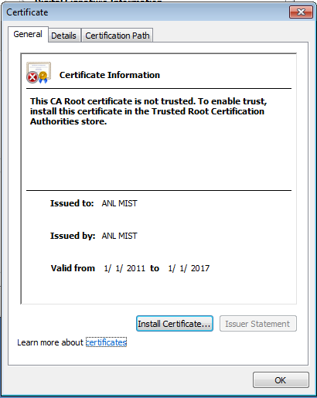
Click Install Certificate…
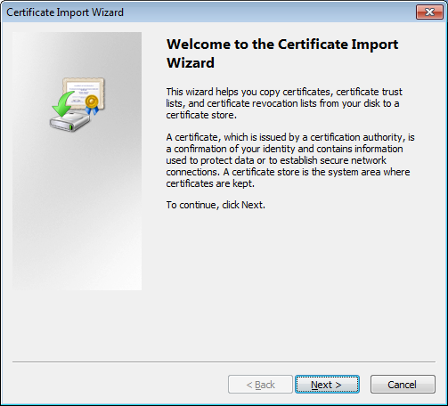
Click Next>

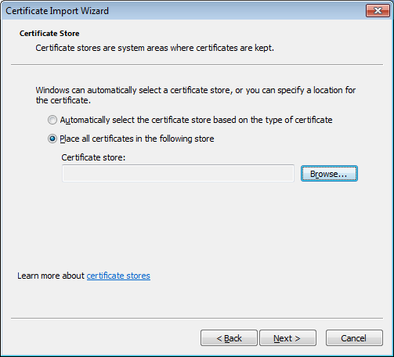
Select Place all certificates in the following store and click Browse…
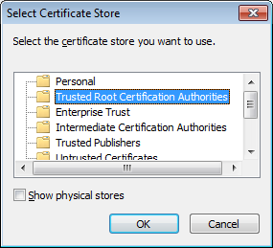
Select Trusted Root Certification Authorities and click OK

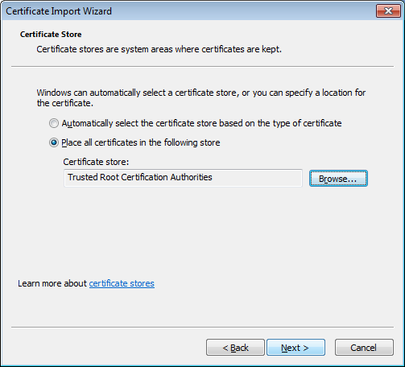
Click Next>

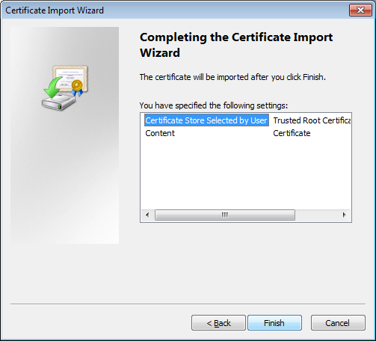
Click Finish

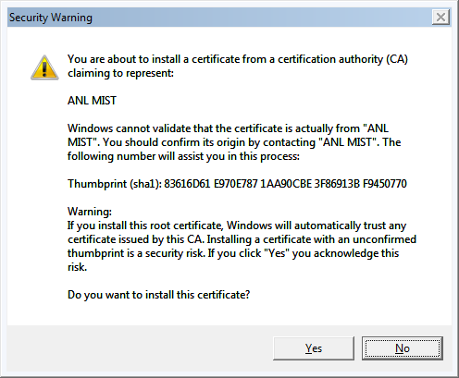
Click Yes
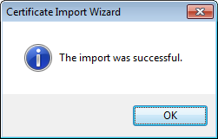
You should get a success message. Click OK

Click OK until you return to the window below
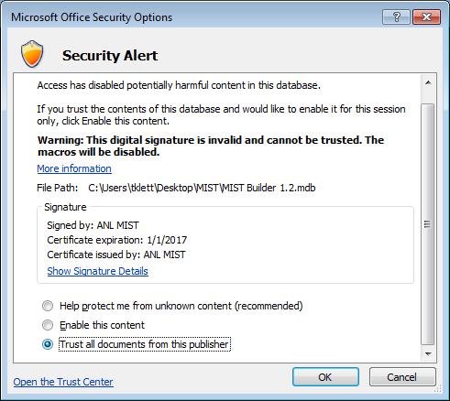
Select Trust all documents from this publisher and click OK
The Builder should open and work correctly. If you get any errors, please send me a screen shot of the error (mklett@anl.gov)

